Bryn Loftness

Hiking 112

Instructor Jim Heaps

**Lower Monument Canyon Trail – September 20th**

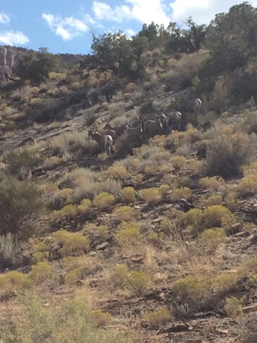

I really liked Lower Monument Canyon trail. I felt it was pretty different from what we were used to doing which I liked. I thought it was an interesting trail being on the rock the whole time instead of like a *trail,* if you know what I mean. We saw a lot of pretty rocks on the ground too which was cool. I thought it was interesting that we started from outside of the Monument and then hiked in. I was wondering if a lot of people do know of/do this trail and if it’s common to use this trail to hike into the Monument. Isn’t that like cheating/against the rules? Anyway, shortly after we began the hike e saw a big group of bighorn sheep right at the beginning of the trail, which was super duper cool. I had been wanting to see some since I haven’t seen any since I got down here. I was pumped.

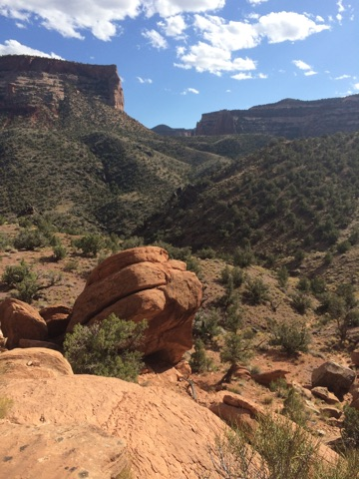

We also saw a few lizards too, which was nice. I really like lizards. They move so quickly and they love to sunbathe—two super cool qualities. Apparently on the last hike Alyssa and Justin saw a few but I didn’t. I was disappointed that they didn’t point any out so I am satisfied that I got the opportunity to see them on this hike. I am really in to seeing the different wildlife this place has to offer.

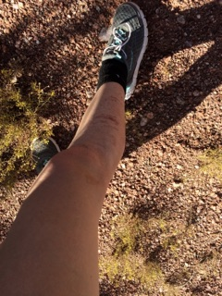

I also fell on my leg in front of a bunch of other classmates during this hike. It was pretty embarrassing, I’m not going to lie. Oh well. I just brushed it off and kept hiking. I made sure to disinfect later.

I am glad I got the opportunity to learn about this hike. I got some really good photos and had a really fun time. I am hoping to take a trip back sometime around sundown because I think the views would be prime.